**Shell Scripting**

**Cat command:**

* Cat command is used to create a file and to view the content in the file. Using cat command, we can only create a single file.

**To create file:**

**Syntax:**

* ]$ **cat >** <file name>

**To view content in file:**

**Syntax:**

* ]$ **cat** <filename>

**Rm command:**

* Rm command is used to remove the files and also directories.

**Syntax:**

* ]$ **rm** <file/directory>
* **-i**: to confirm that user really want to remove file or directory
* **-r**: to recursively remove file or directory even if the file or directory is not empty.

**rm -i:**

* When we this command to delete the file is ask the user that he want to delete the file. (Y(yes) or N(no).)

**Syntax:**

* ]$ **rm -i** <filename>

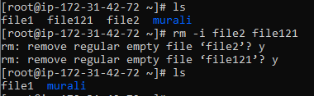

**MV command:**

* MV command is used to move files from one directory to another directory and also used to move the contents of one file to another file.

**Syntax:**

* ]$ mv <source> <destination>

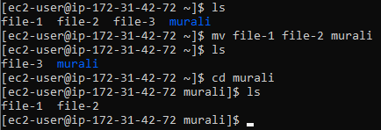

**Ls command:**

* Ls command is used to list the files and directories that are present in system.

**Syntax:**

* ]$ **ls**

To list the hidden files and directories:

* ]$ ls -a
* This command displays the all hidden and non-hidden files.

To list only files:

* ]$ ls -f
* This command displays only the files.

To list only Directories:

* ]$ ls -d
* This command displays only the directories.

To list only Specified files:

* ]$ ls [files initial words] *
* This command will list all the files that start`s with the initials given in the square brackets.

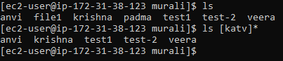

**Expr command:**

* Expr command evaluate the given Regular expression and displays its output.
* It is basically used for Addition, Subtraction, Multiplication,

Division.

**Syntax:**

* ]$ expr <expression>

Addition of two numbers using expr command:

* ]$ expr 12 + 15



Addition of two numbers using variable in expr command:

* ]$ expr $a + $b

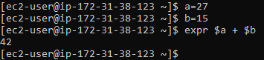

**Log name command:**

* Log name command displays the with which user you have logged in.

**Syntax:**

* ]$ logname



**df command:**

* The df command displays the disk usage and how much free space available.
* Initially it displays the disk usage in KB`s.

**Syntax:**

* ]$ df

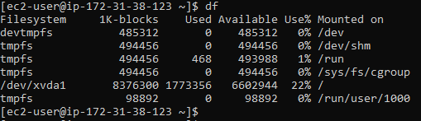

To view disk usage in mb`s:

* ]$ df -h
* This command will display the disk usage in MB`s.

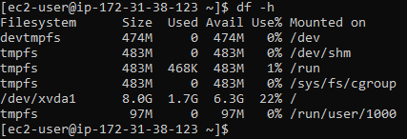

**Uptime command:**

* The uptime command displays the average load on the CPU.
* ]$ uptime



**ULimit command:**

* The ulimit command displays the storage limit of the System.
* ]$ ulimit



**Sort command:**

* The sort command sort`s the contents of the file and displays the output but does not make any changes in the file.
* ]$ sort <filename>

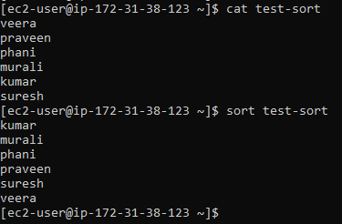

To sort content in the original file:

* ] $ sort -o <filename>
* The above command sorts the content in the file and display the sorted content and also save the changes in file.

**Cut command:**

* Cut command used to cut the section from lines in file.
* It cut the content by byte position, character.

**Syntax:**

* ] $ cut <potion> <filename>
* -b: to cut specific bytes from each line in file, we have to use the -b option after the cut command followed by list of bytes and file name.
* -c: to cut specific characters
* -f: to cut specific field that are separated by delimiters.
* -d: to define the delimiter used in the file

To cut specific fields from a file:

* ] $ cut -f <list of fields> -d “<delimiter>” <filename>
* Emp-data file that containing the employee data

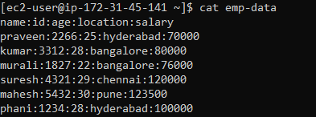

* Cutting two fields from emp-data

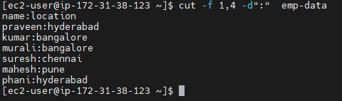

**Note:** Delimiter (which is used in the file to separate fields) must be defined after the list of fields. If the delimiter is not used it will print the whole line.

**Grep command:**

* Grep command is used for content search in files.
* It searches the content based on the given pattern.

**Syntax:**

* ]$ grep “<pattern>” <file name>



To remove the case-sensitive for pattern search:

* -i : is used to remove the case-sensitive for pattern you want to search.
* ]$ grep “<pattern>” -i <file name>

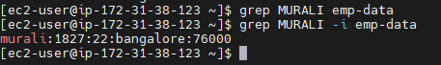

To display the line number of pattern:

* -n : is used to display the line number of the pattern.
* ]$ grep <pattern> -i -n <filename>



To display the lines in file that start with defined pattern:

* ]$ grep ^<pattern> <filename>

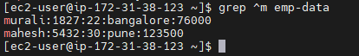

To exclude the lines in file that start with defined pattern:

* -v : is used to exclude the lines that start with pattern that defined
* ]$ grep <pattern> -v <filename>

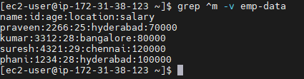

**Head command:**

* Head command used to display top lines of the contents in a file.
* It defaultly display first ten lines.
* We can also define the number of lines to display by giving number of lines after the head .

**Syntax:**

* ]$ head -<no of lines> <filename>

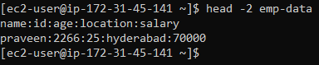

**Tail command:**

* Tail command will display bottom lines of the given file.
* ]$ tail -<no of lines> <filename>

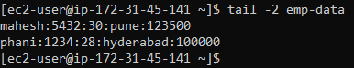

**nl command :**

* nl command will display the line numbers for each line and content in each line.
* ]$ nl <filename>

